Before you start

* You should have a .ipynb file, and .npy files in a folder
  + .ipynb is the Jupyter notebook script.
  + .npy files are the model data, saved as a numpy file.
  + There are multiple variables, from runs with different fire emissions and emission injection heights. The file names mean the following:

|  |  |  |  |  |  |
| --- | --- | --- | --- | --- | --- |
| **Date** | **Variable** | **Temporal resolution** | **Vertical resolution** | **Fire emission** | **Model injection setup** |
| 2015_oct | _PM25 *(µg/ $m^{2})$* | _month | _surface | _FINN | _plumerise |
|  | _AOD | _days | _levels | _FINNpeat | _boundary layer |
|  | _O3 *(ppmv)* |  |  | _nofires | _surface |
|  | _N02 *(ppmv*) |  |  |  |  |
|  | _CO *(ppmv)* |  |  |  |  |
|  | _Temperature *(°C)* |  |  |  |  |
|  | _Rainfall *(mm)* |  |  |  |  |

The fire emissions options are model runs with different fire emissions reading into the model:

FINN is the standard fire emissions, and does not include peat fires.

FINNpeat is FINN with peat fire emissions included.

nofires are runs with no fire emissions.

The model injection setup options are model runs with different methods of injecting the fire emissions:

plumerise is with emissions injected according to a plumerise model.

boundary_layer is with emissions injected across the boundary layer

surface is with emissions injected at the surface.

* Open Jupyter Notebook
  + Go to start and search ‘jupyter notebook’. If Anaconda has been installed correctly, it should appear.
  + A terminal will appear when Jupyter notebook is selected.

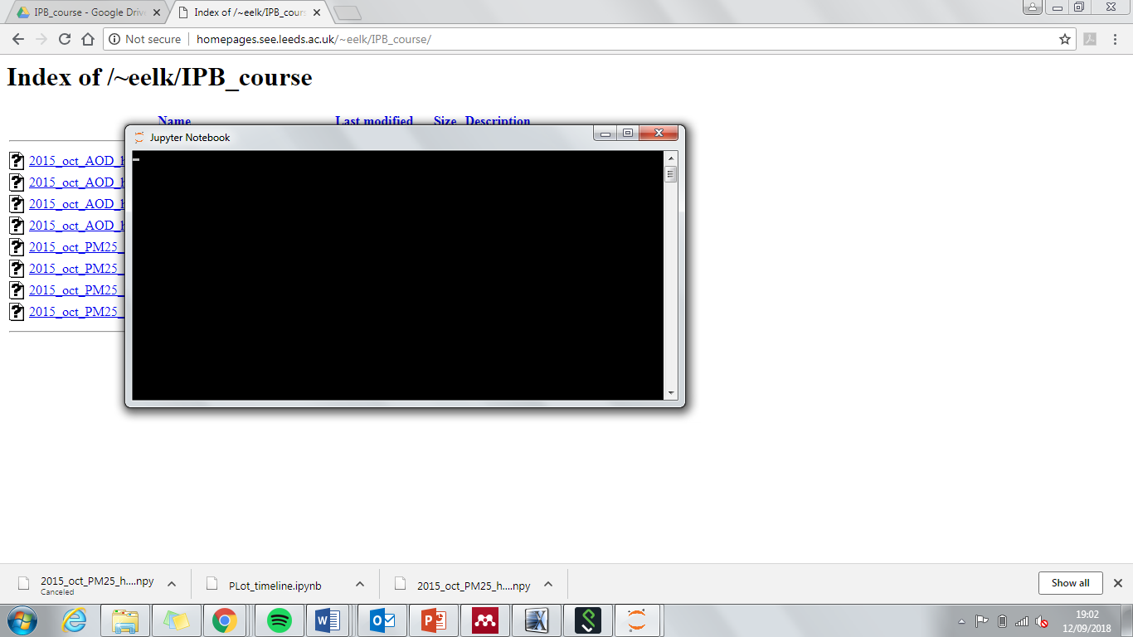

* + Wait, and Jupyter notebook will open in a new tab in the browser.

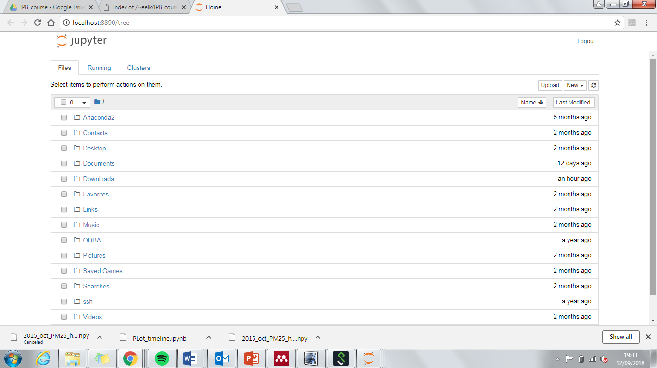

* Open a file.
  + Select ‘Upload’ and upload the Session1 and Session2 files.



* + Double click on a file to open.
* To run code, select a box and click ‘Run’

Session 1 Instructions

This session looks at how using different fire emissions, or turning off all fires, changes the model output.

* The 1st box will plot out monthly model output on a map.
  + Change the file path to the location of the data (downloaded from the Google drive).
  + Change the file name to the file you wish to plot. Try changing the fire emissions and variables.
  + Change the colour bar levels in ‘clevs’

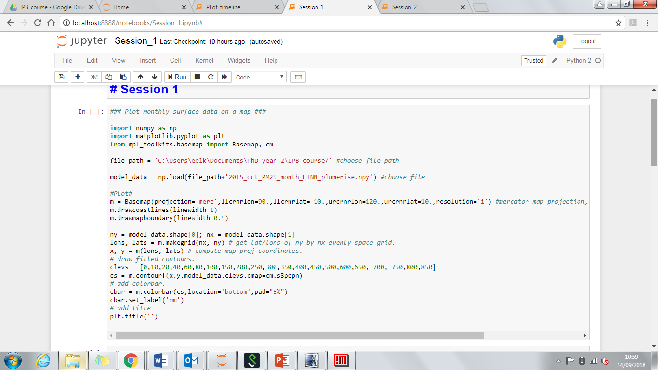

v

* The 2nd box will plot out the difference between model output with and without fires.
  + Change the file path and file name as above.
  + Try with different variables.
* The 3rd box will plot out a timeline of daily model output, averaged over an area, for the three different fire options.
  + Change the file path.
  + Try with different variables.
  + Change the minimum and maximum lat and lon to change the area averaged over.

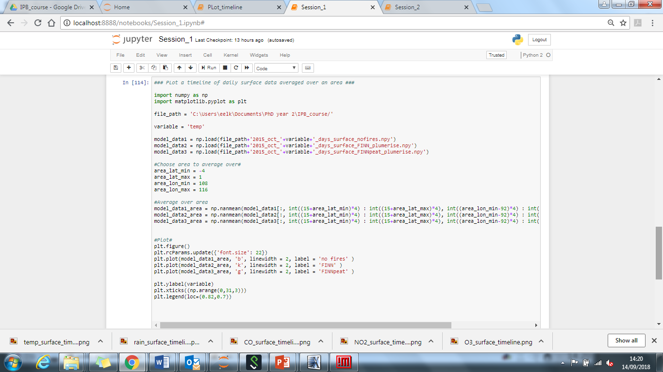

Session 2 Instructions

This sessions looks at how different model options for injecting fire emissions can result in changes in the model output.

* Open the session2.ipynb file from the Google drive
* The 1st box will plot out a variable across the vertical levels of the model, for the three different plumerise options.
  + Change the file path.
  + Try with different variables. Only PM2.5, O3 and NO2 have vertical profiles.
  + Change the minimum and maximum lat and lon to change the area averaged over.
* The 2nd box will plot out model surface data on a map. This is the same code as from sessions 1
  + Change the file path
  + Try with different variables, and different plumerise options.